Week5 Gate 5 Presentation:
Playwright Automation Testing Framework Documentation
1. Project Overview
Objective
This project uses Playwright and TypeScript to automate testing for a Point of Sale (POS) application. It verifies important features like offline sales, refunds, retry mechanisms, rollback, and logging. The framework also generates screenshots, videos, traces, and reports to help identify and fix issues quickly.
2. Tools & Technologies
Tool | Purpose
Playwright | Browser Automation
TypeScript/JavaScript | Programming Language
Node.js | Runtime Environment
npm | Package Management
Playwright HTML Report | Reporting
Git | Version Control
GitHub/GitLab | Repository Management
3. Project Structure
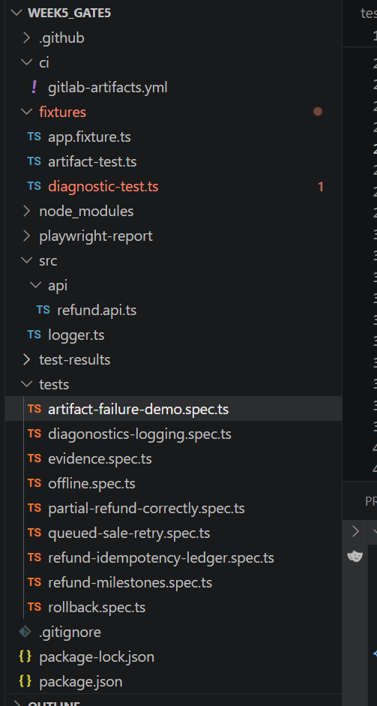
4. Framework Features
Playwright Features Used
- Auto Waiting
- Built-in Assertions
- Parallel Execution
- Cross Browser Testing
- Screenshots
- Trace Viewer
- Video Recording
- Retry Mechanism
Failed Test Case
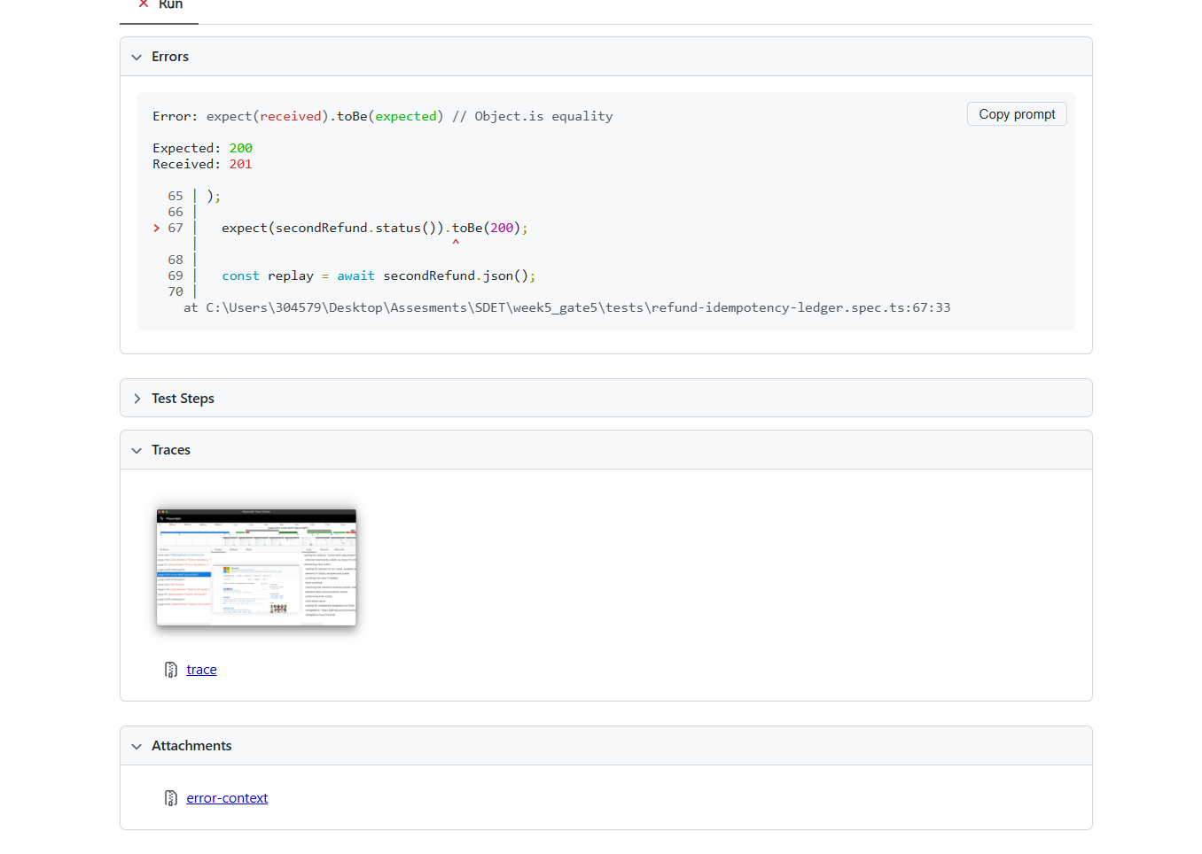
Refund cannot be don’t twice that the reason its failing now I fixed idempotency key that how I made it pass
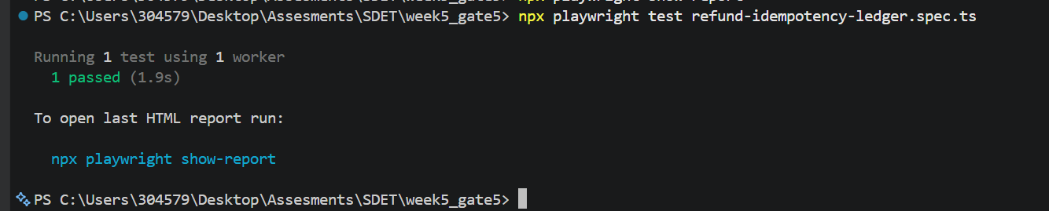

Now In playwright.config.ts I’m creating to trace to take screenshots , video only on failure so I’m intentionally failing the artifact to demonstrate how its taking
On failure playwright takes screenshots and videos

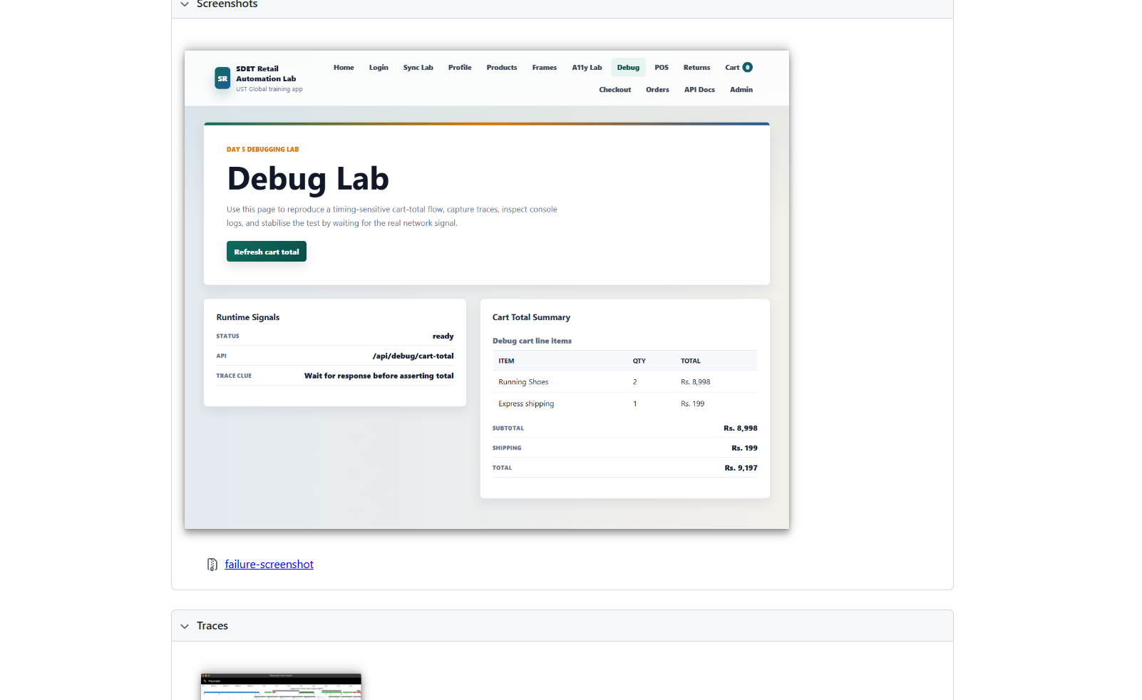

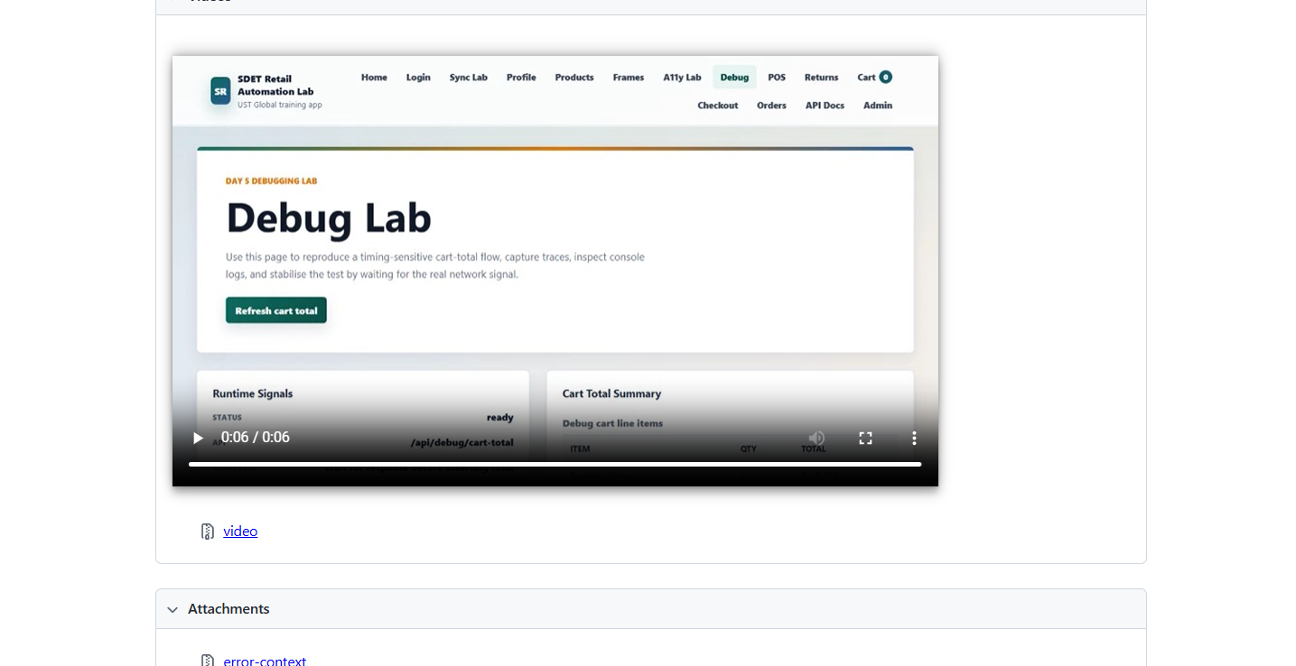

Flaky Test
Intentionally introduced a flaky test to demonstrate the flaky ness
When a test is running multiple times sometimes it will pass and sometimes it will fail it is flaky I’m running it for 50 times.
Command : npx playwright test tests/flaky-demo.spec.ts --repeat-each=50
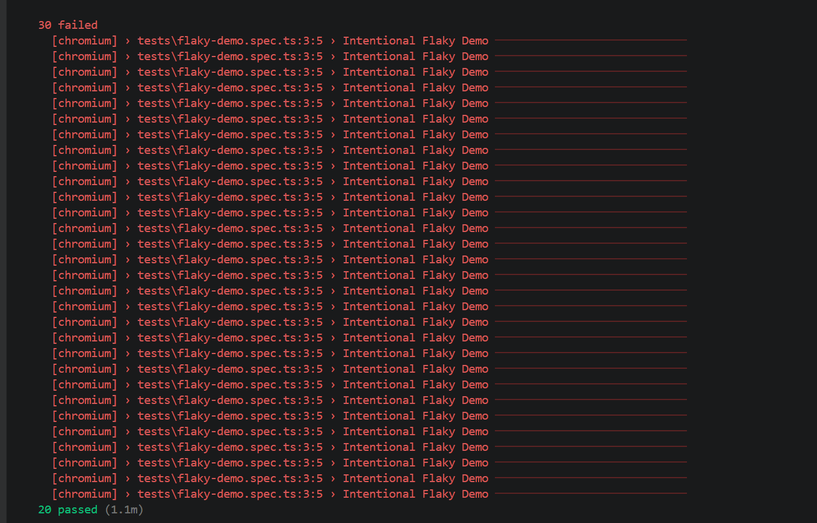
Its passing for 10 times only

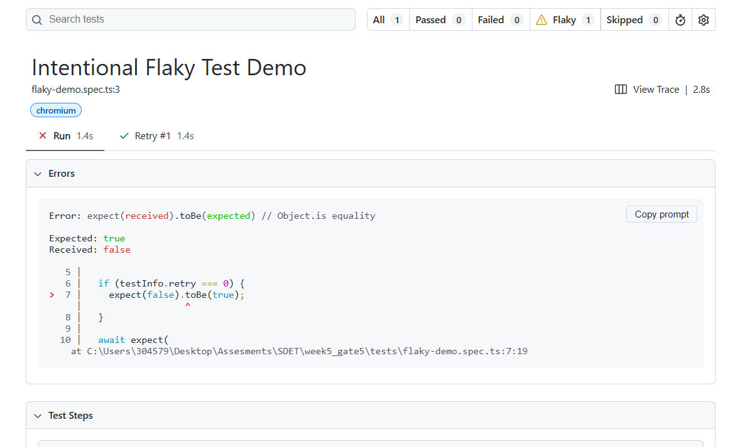

Json response attaching on passing
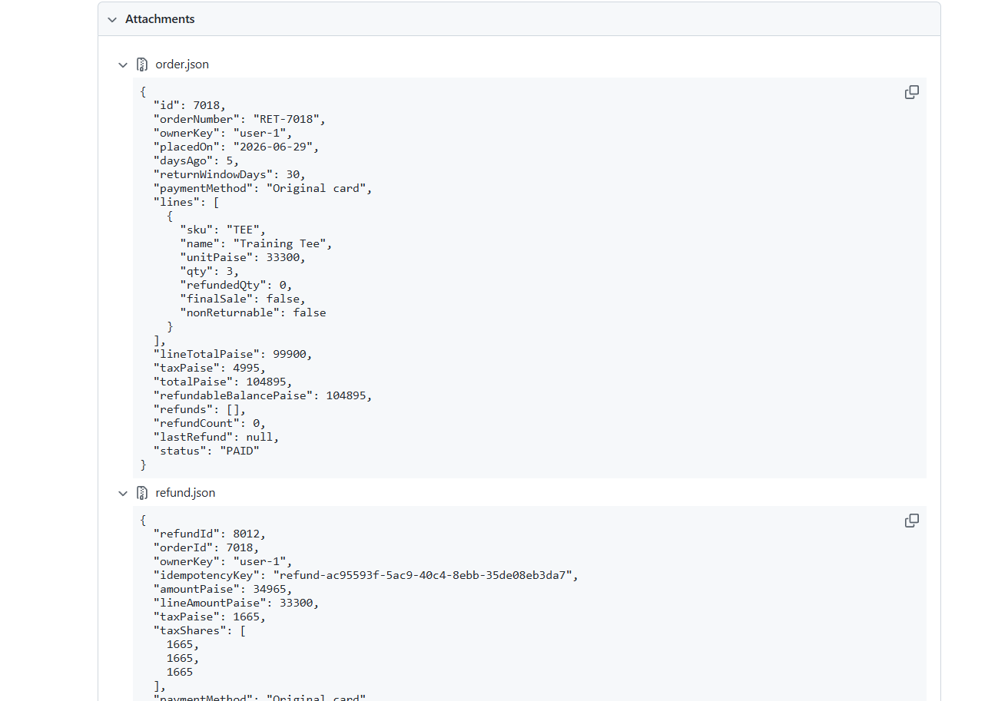

Test Files:
artifact-failure-demo.spec.ts
Intentionally fails a test to generate playwright artifacts such as screenshots, videos, traces, and logs for failure analysis.
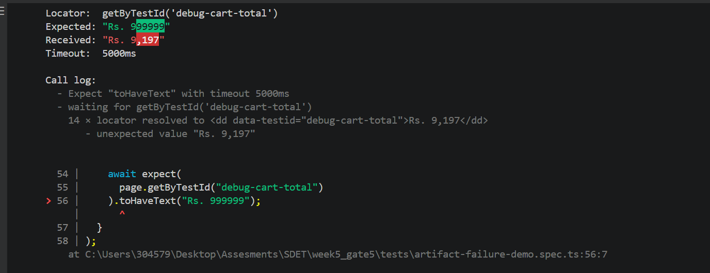
Again, fixed it:
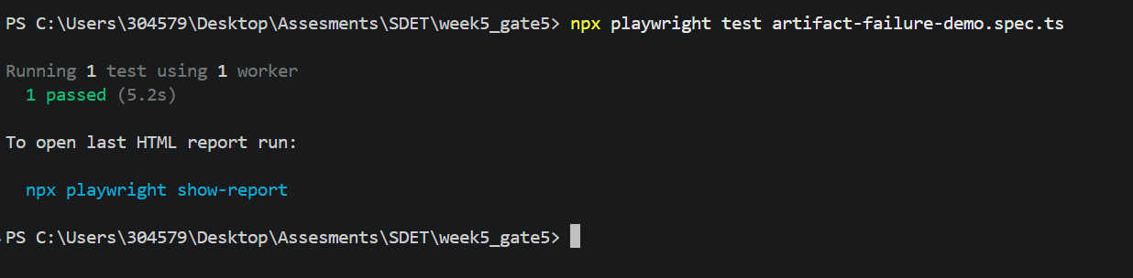

Diagnostics-logging.spec.ts
Verifies structured logging, correlation IDs, and sensitive data redaction to improve debugging and diagnostics.
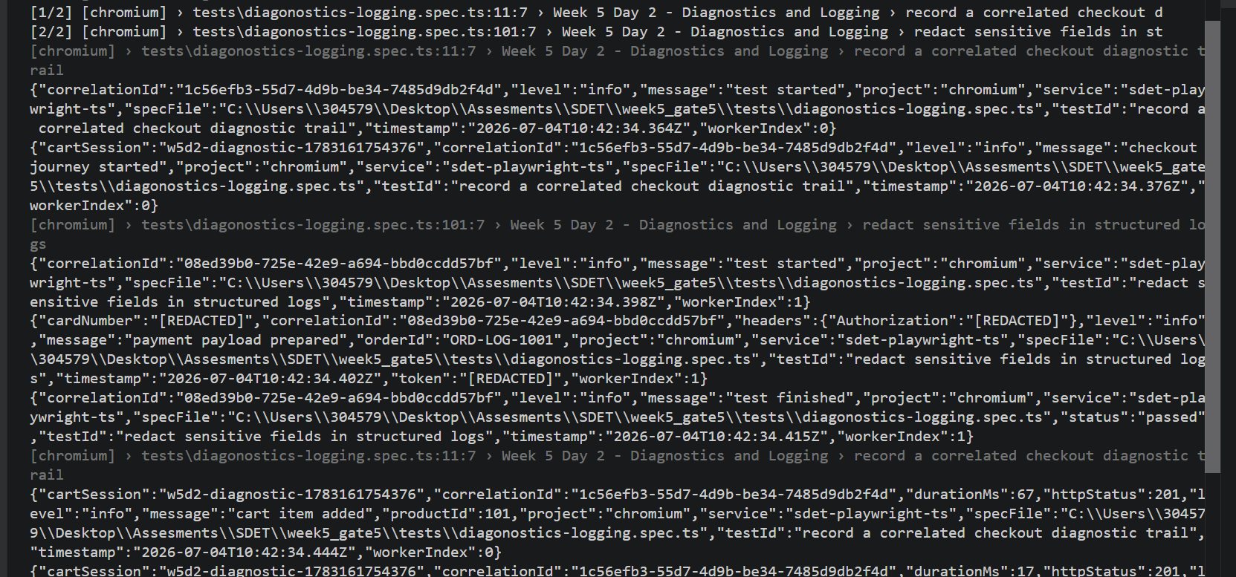
evidence.spec.ts
Tests the complete refund workflow, including partial, full, over-refund, and connection is unavailable.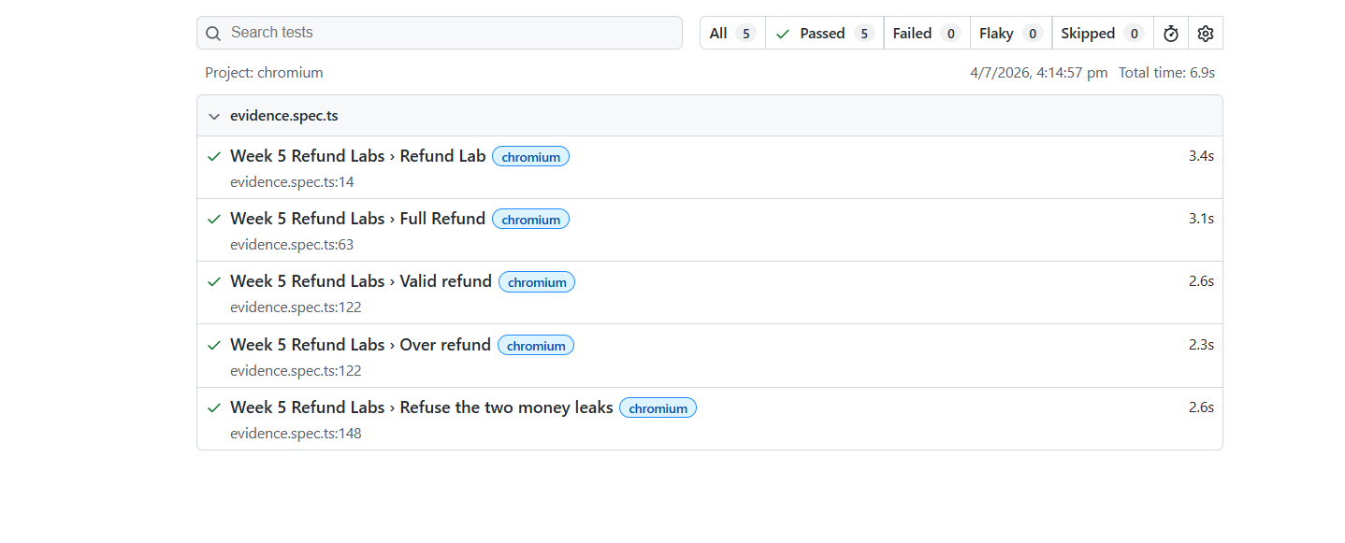
Offline.spec.ts
Verifies that the application displays the correct offline message when the network connection is unavailable.
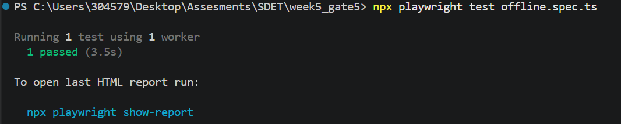
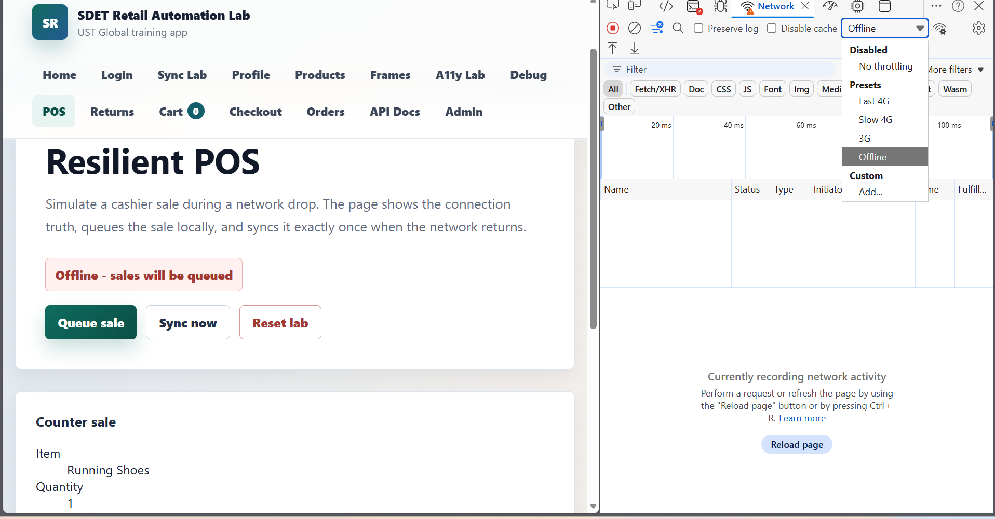

Partial-refund-correctly.spec.ts
Validates that partial refund amounts and tax calculations are accurate.
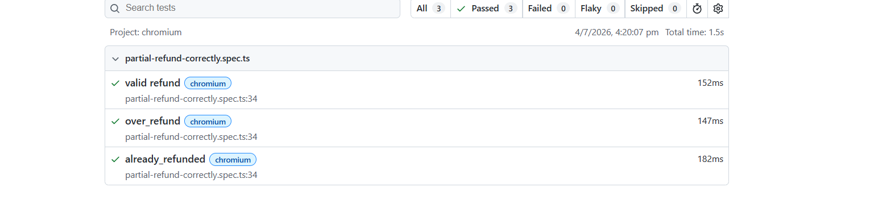
Queued-sale-retry.spec.ts
Ensures queued sales are automatically retried after reconnecting and use the same idempotency key to prevent duplicates.
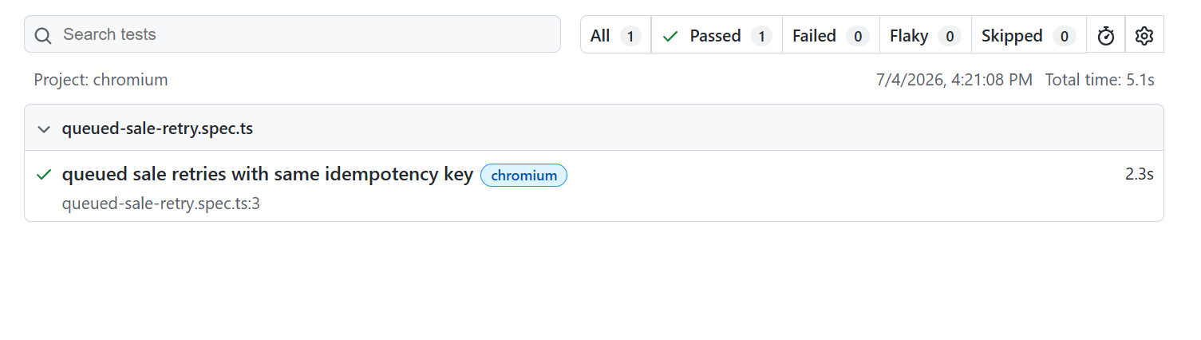
Refund-idempotency-ledger.spce.ts
Verifies that duplicate refund requests are prevented and the refund ledger remains consistent.
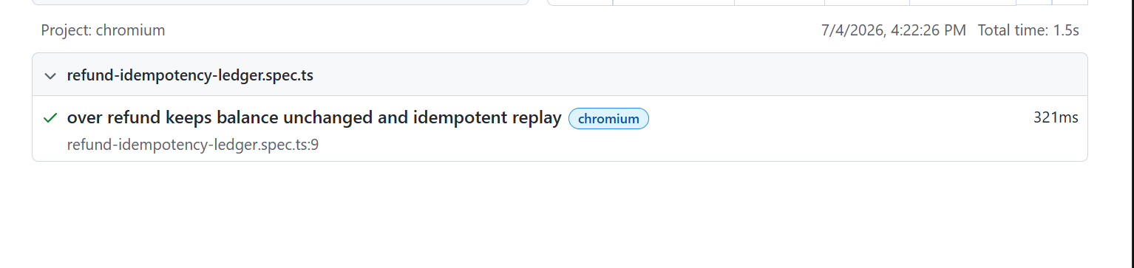

Refund-milestone.spec.ts
Validates all refund milestones, including full refund, partial refund, refund eligibility, over-refunded rejection, and idempotency.
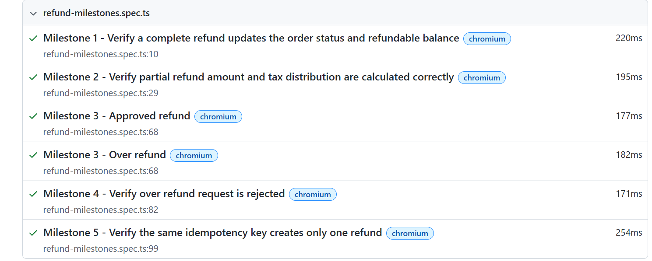

Rollback.spec.ts
Verifies that failed sale synchronization is rolled back correctly and the application display the appropriate error message.
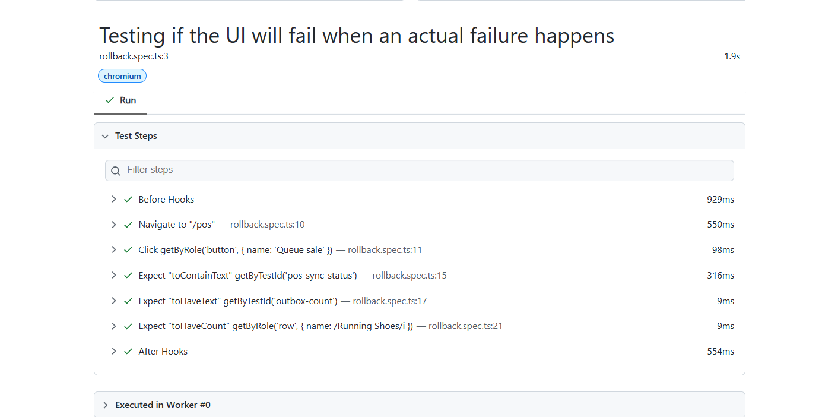

Run all test cases in once
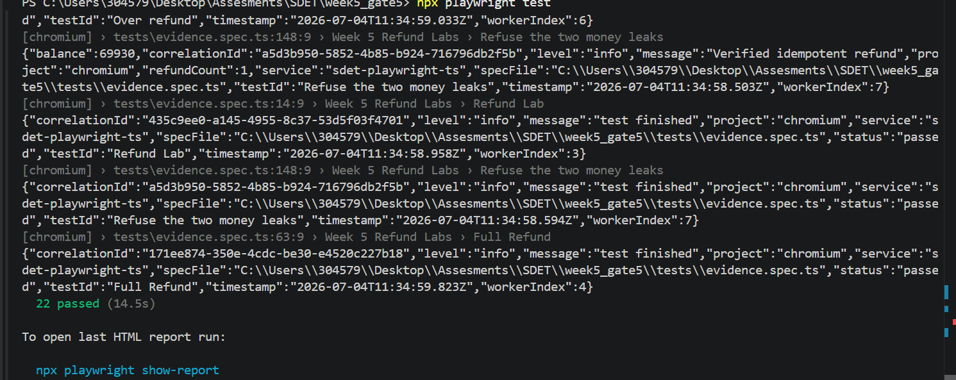
5. Test Execution
Install Dependencies
npm install
Install Browsers
npx playwright install
Run All Tests
npx playwright test
Run Headed Mode
npx playwright test --headed
Run UI Mode
npx playwright test –ui

6. Reporting
Generate Report
npx playwright show-report
Report Includes:
- Passed Tests
- Failed Tests
- Execution Time
- Screenshots
- Videos
- Traces

7. Screenshots & Traces
Screenshot on Failure
Purpose:
- Easier Debugging
- Visual Verification
Trace Viewer
Open Trace:
npx playwright show-trace trace.zip
Benefits:
- Step-by-Step Execution
- Network Calls
- Console Logs
- DOM Snapshots

Record Traces
playwright.config.ts
use: {
trace: ‘retain-on-failure’
}
Open Trace
npx playwright show-trace trace.zip

Screenshots
Capture Screenshot on Failure
playwright.config.ts
use: {
screenshot: 'only-on-failure'
}

Videos
Record Video
playwright.config.ts
use: {
video: 'retain-on-failure'
}

Parallel Execution
Run Tests in Parallel
npx playwright test --workers=4
Run Sequentially
npx playwright test --workers=1

Useful Commands
List All Tests
npx playwright test --list
Update Snapshots
npx playwright test --update-snapshots
Run Last Failed Tests
npx playwright test --last-failed

Clear Report Folder
rm -rf playwright-report
14. Conclusion
The Playwright automation framework provides a scalable, maintainable, and reliable solution for automated web application testing. By using Page Object Model, reusable components, and Playwright's built-in features, the framework ensures efficient test execution and high-quality software delivery.

